- Logo will be on the left top corner – increase size
- Move the language feature on the right side (don’t activate this feature for now)
- Keep the ‘Enter the Lab’ button right where it is.
- Move the panel options towards inner end, increase the font size of the panel options

- Justified alignment of the paragraphs

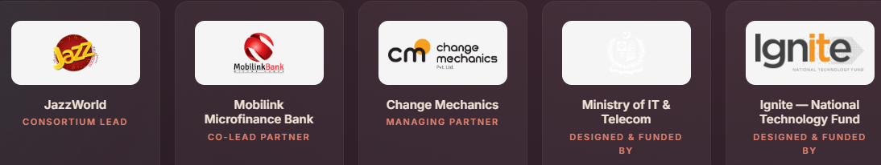
- Remove the white background behind the logos, use png transparent background logos.
- MoITT’s logo isn’t visible
- Separate consortium partners from Govt funding Org (MoITT & Ignite)
- One liner description of each partner, entity.
Description of each partner:
- Ministry of IT & Telecommunication (MoITT): The Government of Pakistan’s lead ministry for shaping national technology policy, accelerating digital transformation, and enabling inclusive economic development.
- Ignite – National Technology Fund: The government-backed funding and innovation agency supporting technology startups, entrepreneurship, research, and incubation ecosystems across Pakistan.
- Jazz: Pakistan’s leading digital connectivity company, bringing technological expertise, nationwide reach, and enterprise innovation to the WISE Lab consortium.
- Mobilink Bank: Pakistan’s leading digital microfinance bank, advancing financial inclusion, digital banking, and growth opportunities for women entrepreneurs and MSMEs.
- Change Mechanics: An innovation and ecosystem-development organization bringing programme design, entrepreneurship support, and implementation expertise to WISE Lab.
- Remove these tags

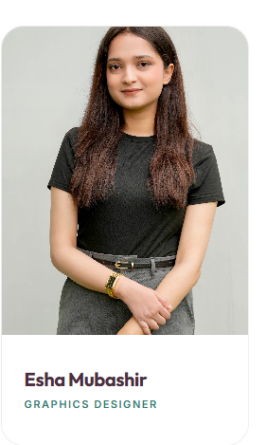
- Keep the headspace – adjust accordingly


- Use this link instead, that page was removed:
https://www.linkedin.com/company/women-innovation-and-startup-empowerment-lab/?viewAsMember=true

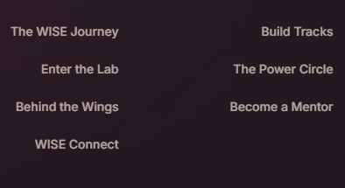
- Add: Careers at WISE

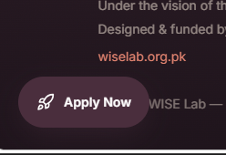
- Fix the over lap
- Give this button a diff colour to pop out

